Sadiq Public School

Do the right, fear no man

**Subject: Mathematics Class: P6 Day: Saturday Date: 16-11-2024**

***Topic:* Angle**

**Lesson [Chap.10] This lesson is about angles formed by two parallel lines and a transversal**

**Content**

## Corresponding angles,Alternate angles and Interior angles

**Corresponding Angles Formed by Parallel Lines and Transversals**

If a line or a transversal crosses any two given parallel lines, then the **corresponding angles formed have equal measure**. In the given figure, you can see, the two [parallel lines](https://byjus.com/maths/parallel-lines/) are intersected by a transversal, which forms eight angles with the transversal. So, the angles formed by the first line with transversal have equal corresponding angles formed by the second line with the transversal.

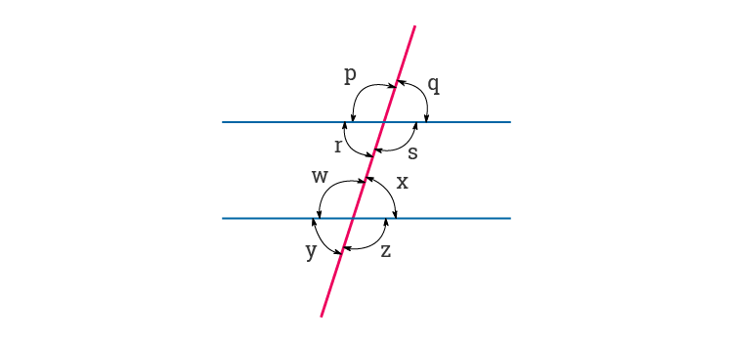

Corresponding Angles Formed by Parallel Lines and Transversals

**All corresponding angle pairs in the figure:**

* ∠p and ∠w
* ∠q and ∠x
* ∠r and ∠y
* ∠s and ∠z

**Alternate Angles**

When two straight lines are cut by a transversal, then the angles formed on the opposite side of the transversal with respect to both the lines are called alternate angles. Hence, it is those angles that have different vertices and lie on the alternate sides of the [transversal](https://www.cuemath.com/geometry/transversal/).

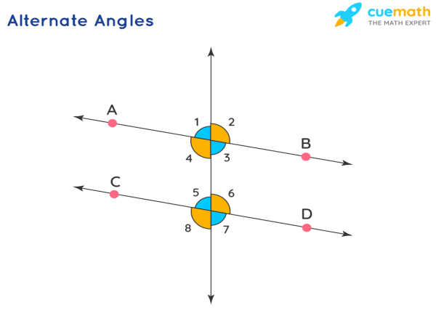

The pairs of alternate angles in the above figure are:

* ∠3 and ∠5
* ∠4 and ∠6
* ∠1 and ∠7
* ∠2 and ∠8

**Interior Angles of Parallel Lines:**The angles that lie in the area enclosed between two [parallel lines](https://www.cuemath.com/geometry/parallel-lines/) that are intersected by a transversal are also called interior angles. In the below figure (b), L1 and L2 are parallel, and L is the transversal. The angles ∠1, ∠2, ∠3, and ∠4 are interior angles.

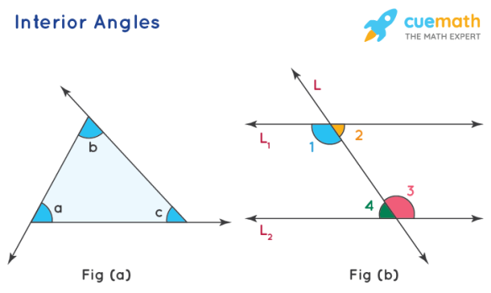

### Solved Example

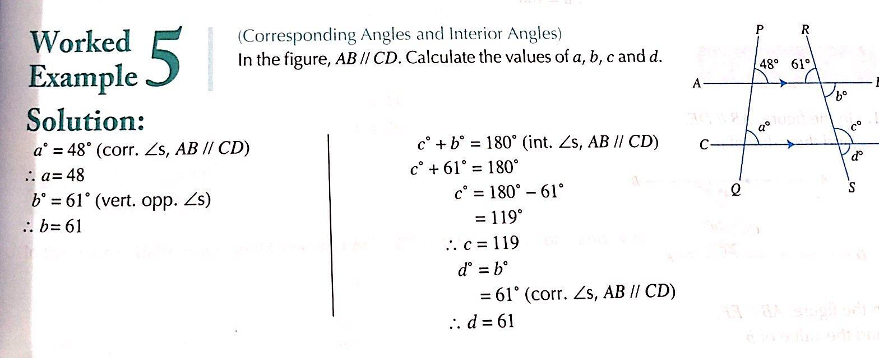

Q NO 1: Calculate the value of unknown

|  |  |
| --- | --- |
| C:\Users\admin\Desktop\ayb.jfif | C:\Users\admin\Desktop\2.jfif |

**NOTE:** Unsolved questions are for H.W

************************************