

Sadiq Public School

Do the right, fear no man

**Subject: Chemistry Class: C1 Day: Saturday, 16 November 2024**

**This lesson is about revision of covalent bonds and macromolecules.**

Non-metal atoms react with one another to attain the electronic configuration of the noble gas. They do by sharing electrons. What happens when the electrons are shared? What are Macromolecules? What are their properties? What are allotropes? What are allotropic forms of carbon?

**B: Information:**

Covalent bond: A covalent bond is a chemical bond that involves the mutual sharing of electron pairs between atoms.

To explain it let us consider example of formation of chlorine molecule. Each atom of chlorine has seven electrons in its outermost shell. Its electronic configuration is, 2,8,7, which means it is one short of the stable octet in the third shell. It achieves stability by sharing one electron with another chlorine atom, which in turn shares one of its electrons.

 

Types of covalent bonds:

There are three types of covalent bonds

* Single covalent bond
* Double covalent bond
* Triple covalent bond

Macromolecules: These have giant, covalent molecules with extremely large molecular structures. They are very stable, as all atoms are joined together by strong covalent bonds to give a giant three-dimensional lattice. Often the lattice is in tetrahedral in shape, as every atom is covalently linked to four others.

* Examples of such macromolecules are diamond and sand

Properties of macromolecules:

1. Substances with giant structures have very high melting and boiling points
2. Giant molecular structures do not conduct electricity. (Except graphite)
3. They are insoluble in both water and organic solvents.

This is because in giant molecular substances, all the atoms are held together by strong covalent bonds. And forces of attraction between the giant molecular structure are solvent molecules are not strong enough to break the strong covalent bonds.

Allotropes:

An element exists in two or more different forms, in the same physical state, known as allotropes of the elements. Allotropes are different structural modifications of an element; the atoms of the element are bonded together in different manner. Diamond and graphite are allotropes of carbon.

Diamond: Each carbon atom is covalently bonded to four other atoms, which, in turn, are bonded to four other atoms.It is difficult to break these strong covalent bonds. As all valence electrons are bonded, so diamonds do not conduct electricity.

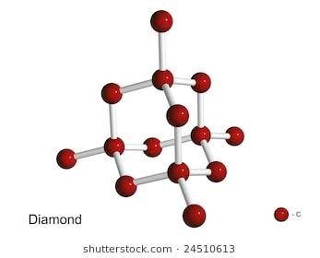 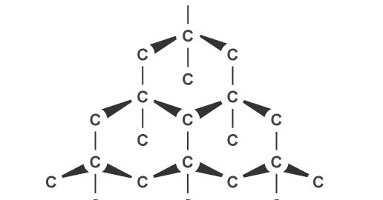

Graphite: It is soft, slippery, unreactive and a good conductor of electricity. Therefore, It is often used to make dry lubricants an inert electrode. It can even be mixed with clay to make pencil. Each carbon atom is covalently bonded to three other carbon atoms, which, in turn are bonded to three more carbon atoms. This forms a continuous layer of hexagons.

Each carbon atom has one outer electron that is not used to form covalent bonds.

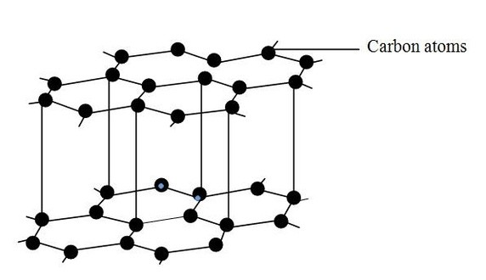

1. Please read page 70 and 71 of your text book. (C. N. Prescott)
2. Please watch this video on macromolecules. (Diamond and graphite)

(<https://www.youtube.com/watch?v=tGH0mXCcEFU>)

**C: Synthesis / Absorbing the information**

1. Write down properties of covalent compounds.
2. Write down properties of macromolecules.

**D: Practising**

1. Write two uses of each graphite and diamond.
2. Write down two similarities and two differences of graphite and diamond?
3. Draw dot and cross diagram of O2, CCl4, C2H6, N2, C2H2, CO2.

**F: Feedback**

* It essential for all students to access the portal during this period to review the lesson and complete the assigned homework.
* If you have any question about the above topic, you can ask me through email and I will reply as soon as possible.

|  |  |  |  |  |
| --- | --- | --- | --- | --- |
| Class | Teacher’s name | Teacher’s abbreviation | Teacher’s Email Address | Instructions |
| C1C | Samina Aijaz | SA | [saminaijaz907@gmail.com](mailto:saminaijaz907@gmail.com) | C1C students will send their home assignments to their subject teacher (SA) for checking and getting feedback |
| C1D | Azkia Khan | AHA | Azkia.khan95@gmail.com | C1D students will send their home assignments to their subject teacher (AHA) for checking and getting feedback |
| C1E | Abdul Rehaman | HAR | Khawajaabdulrahman12@gmail.com | C1E students will send their home assignments to their subject teacher (HAR) for checking and getting feedback |
| C1GA | Shahla Muqtadir | SM | shahlamuqtadir@gmail.com | C1GA students will send their home assignments to their subject teacher (SM) for checking and getting feedback |
| C1GB | Sumiyya Sami | SS | sumiyyasami1989@gmail.com | C1GB students will send their home assignments to their subject teacher (SS) for checking and getting feedback |